**Employee Data Analysis using Excel**



STUDENT NAME:D Thangam

REGISTER NO:312204440

DEPARTMENT:BCOM (general)

COLLEGE:Annai violet college of arts and

science 

**PROJECT TITLE**

**Employee Performance Analysis**

**using Excel**

**AGENDA**

1.Problem Statement

2.Project Overview

3.End Users

4.Our Solution and Proposition

5.Dataset Description

6.Modelling Approach

7.Results and Discussion

8.Conclusion

**PROBLEM STATEMENT**

·Analysing employee performance to track

their working skills and to motivate the low

level

employees by various tasks .

·To track the performance and give

rewards to improve the current

performance.





**PROJECT OVERVIEW**

d In this project we known about the employees

how they perform by various graph and pivot

table

dEmployee performance analysis is important

to identify the performance level toward

the project and improve their level by

assigning new taks to emerge themselves .

5



**WHO ARE THE END USERS?**

**dEmployees**

**dOrganisations**

**dEmployers**



**OUR SOLUTION AND ITS VALUE PROPOSITION**

d Filtering-remove missing

dCharts -visualization repots

dPivot tabe-summary

dConditional formatting-identify missing

d Formula -performance level

**Dataset Description**

Employee data set -the employee datas are taken from the Kaggleto analysis employe performance

9 features

Employee ID:Unique identifier for each employee in the organization.

First Name:The first name of the employee.

Title: Thejob title or position of the employee within the organization

.Business Unit:The specific business unit or department to which the employee belongs.

Employee Status:The current employment status of the employee(e.g.,Active,On Leave,Terminated)

Employee Type:The type of employment the employee has(e.g.,Full-time,Part-time,Contract).

**THE "WOW"IN OUR SOLUTION**

·=IFS(Z3O>=5,"VERY

HIGH“,Z3O>=4"HIGH",Z3O>=3"MED”,"TRUE","LOW"

**MODELLING**

Data collection

dThe employee performance analysis table are taken from the website called Kaggle

dFrom the data we had some missing figures to identify the missing terms we use conditional techniques to identify the missing terms like exit

data etc..

dThen we used filtering and sorting to fill the missing figues

Features collection

dPivot table

dCharts

**dConditional**

10

**Pivot table**

1.Click insert

2.From the insert bar click pivot table in new excel sheet

3.Select business unit and drag it in row

4.Then select performance level and drag it

in column 5.Select gender in value

Performance level

dFrom the pivot table we can see the analysis for female male and all and we can

access all type of employees by inerting slicers to see how many are full time

,part time and

contract based employees.

dlnsert graph for better analysis the graph shows the accurate levels and the

performance of employees.We can see the various graph by changing the

options in the graph options.

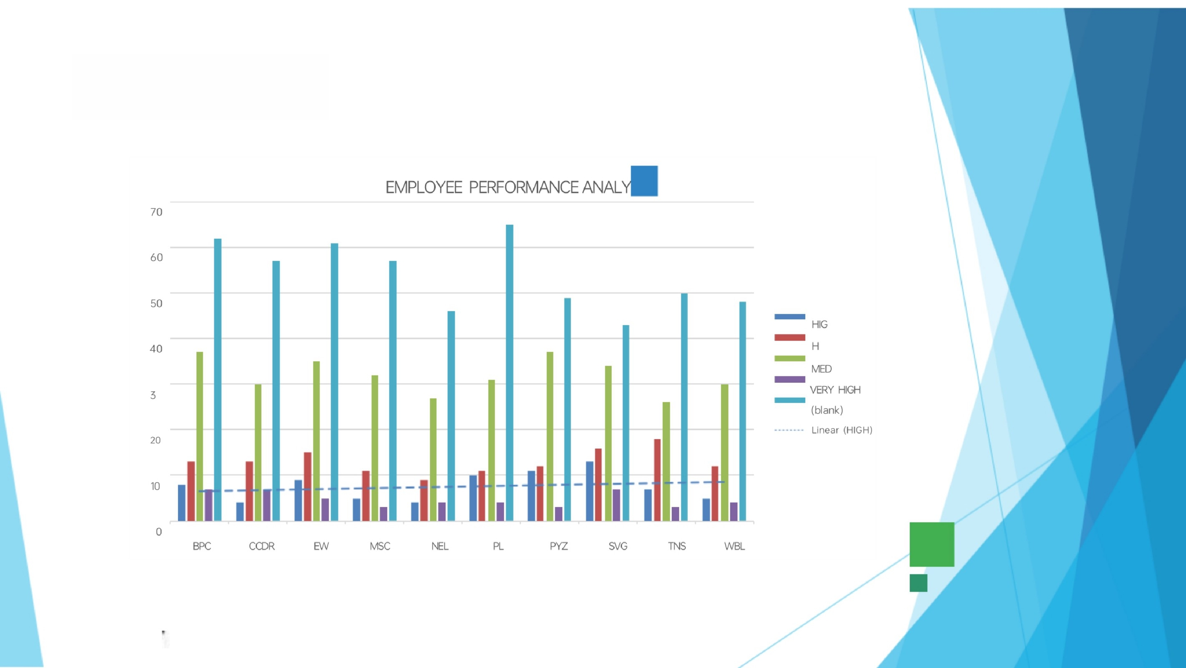**RESULTS**

2

**Pie chart for high level performance**

HIGH

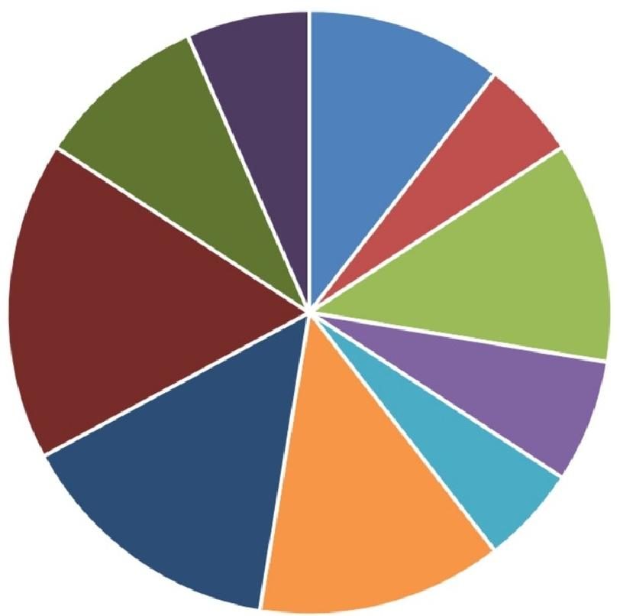

 BPC

■ CCDR

■EW

■ MSC

■ NEL

■ PL

■ PYZ

■SVG

■ TNS

■WBL

**conclusion**

□ From the above analysis the low level,medium leve

to be improved by assigning various tasks and

training in their field

口 The current high and very high level employees are

improve their intensity by rewards and appreciations

towards their growth to increase their participation

and to give more potential towards their project.